*A Progress Report*

*on*

**IMAGE EDITOR**

*carried out as part of the course: AI2270*

*Submitted by*

***Amisha Banait***

***229310262***

***IV-AIML***

*in partial fulfilment for the award of the degree*

*of*

**BACHELOR OF TECHNOLOGY**

In

**Computer Science and Engineering(AIML)**

**Department of Artificial Intelligence and Machine Learning**

**School of Computer Science & Engineering**

**Manipal University Jaipur,**

***April 2024***

**ACKNOWLEDGEMENT**

This project would not have completed without the help, support, comments, advice, cooperation, and coordination of various people. However, it is impossible to thank everyone individually; I am hereby making a humble effort to thank some of them.

I acknowledge and express my deepest sense of gratitude of my internal supervisors **Dr. Deepak Panwar and Dr. Preeti Narooka** for their constant support, guidance, and continuous engagement. I highly appreciate their technical comments, suggestions, and criticism during the progress of this project “**Image Editor**”.

I owe my profound gratitude **Dr. Santosh Kumar Vishwakarma**, Head, Department of Artificial Intelligence and Machine Learning, for his valuable guidance and facilitating me during my work. I am also very grateful to all the faculty members and staff for their precious support and cooperation during the development of this project.

Finally, I extend my heartfelt appreciation to my classmates for their help and encouragement.

**229310262 Amisha Banait**



**Department of Computer Science and Engineering**

**School of Computing & Information Technology**

Date: 22 April 2024

**CERTIFICATE**

This is to certify that the project entitled “***IMAGE EDITOR***" is a bonafide work carried out as ***Project Based Learning (Course Code: AI2270)*** in partial fulfilment for the award of the degree of Bachelor of Technology in CSE-AIML, under my guidance by ***Amisha Banait*** bearing registration number **229310262**, during the academic semester *IV of year 2023-24.*

Place: Manipal University Jaipur, Jaipur

Name of the project guide: **Dr. Deepak Panwar and Dr. Preeti Narooka**

Signature of the project guide: ___________________________________

**ABSTRACT**

This Project is based on Python programming. Python is the most popular programming language or nothing wrong to say that it is the next generation programming language. Python has vast libraries for various fields such as Machine Learning (Numpy, Pandas, Matplotlib), Artificial intelligence (Pytorch, TensorFlow), and Image editing modules (PIL). This project mainly uses tkinter, OpenCV and PIL modules.

The idea of the project is to do basic image editing functions like adjusting the brightness and contrast, adding filters etc. It involves in importing the image first and editing the picture according to the user.

The project is currently in Phase 0, where it is in its base state and under development. It can do the basic functions of an image editor and I am planning to develop this project further where it is a fully functional image editor with a wide variety of tools and functions.

**CONTENTS**

Page No.

1. Introduction 1
   1. Objective of the project
   2. Brief description of the project
   3. Technology Used
      1. Software Used
      2. Hardware Requirement
2. Design Description 3
   1. Flow Chart
3. Input/Output Form Design 4
   1. Import Image
   2. Edit Options Selection
   3. Display and Output
   4. Save Image
4. Source Code 6
5. Output Screenshots 10
6. Conclusion and Future scope 13
7. Bibliography 14

**INTRODUCTION**

**Objective of the Project:**

Develop a simple image editing software using Python programming and related modules.

Utilize Python modules such as Tkinter, OpenCV, and PIL for creating a user-friendly interface and implementing basic image editing functionalities.

Showcase the ease and flexibility of Python for creating effective image editing software compared to other programming languages.

**Brief Description of the Project:**

Image editing software is ubiquitous across electronic devices like mobile phones and computers. This project aims to leverage Python and its modules to create a basic yet functional image editing application.

Python modules such as Tkinter are used to create the graphical user interface (GUI), while OpenCV and PIL are utilized for image editing functionalities.

OpenCV provides a comprehensive set of computer vision and machine learning algorithms, making it suitable for tasks like object detection, image enhancement, and more.

The project focuses on basic image editing tasks such as removing unwanted elements, adjusting geometry, color changes, and adding special effects.

Python's simplicity and readily available modules make it an ideal choice for this project, enabling effective code development with minimal complexity.

**Technology Used:**

**Software Used:**

Python IDE v3.12

PyCharm

**Hardware Requirements:**

Since the project is developed using Python and its libraries, it doesn't have specific hardware requirements.

It can be run on a normal PC that supports Python without the need for specialized hardware.

**DESIGN DESCRIPTION**

Figure 1: Flowchart of the project**INPUT/OUTPUT FORM DESIGN**

The user interface (UI) of the image editor is designed to provide intuitive interaction for importing, editing, and saving images. The UI components are implemented using the Tkinter library, a standard GUI toolkit for Python.

**3.1. Import Image**

Upon launching the application, users are presented with an option to import an image file from their device. This is achieved through a file dialog window that allows users to browse and select the desired image file. Supported file formats include common image formats such as JPEG, PNG.

**3.2. Edit Options Selection**

After importing an image, users are presented with a set of editing options displayed in a toolbar. These options include:

* Rotate: Allows users to rotate the image by 90 degrees.
* Apply Colour Filter: Provides a selection of predefined colour filters that users can apply to the image.
* Undo: Enables users to undo the last editing action and revert to the previous state of the image maximum up to 5 steps.
* Save: Allows users to save the edited image to their local storage.
* Close: Allows users to close the window.

**3.3. Display and Output**

Throughout the editing process, the image is displayed in a central canvas area within the application window. This canvas dynamically updates to reflect the changes made by the user. Additionally, the edited image can be previewed before saving.

**3.4. Save Image**

After applying desired edits, users can save the edited image to their local storage. A file dialog window allows users to specify the filename and destination folder for the saved image. Supported file formats for saving include the same formats supported for importing.

The input/output form design ensures a seamless and user-friendly experience for editing and saving images within the application.

**SOURCE CODE**

**OUTPUT SCREENSHOTS**

Figure 1: Main Window.

Figure 2: Dialog window opened to import an image.

Figure 3: Image displayed after importing.

Figure 4: Image displayed after adding color filter.

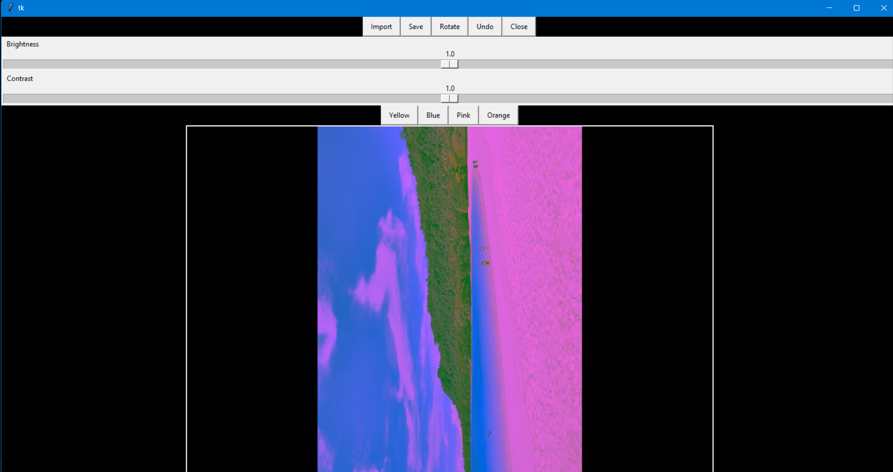

Figure 5: Image displayed after rotating once.

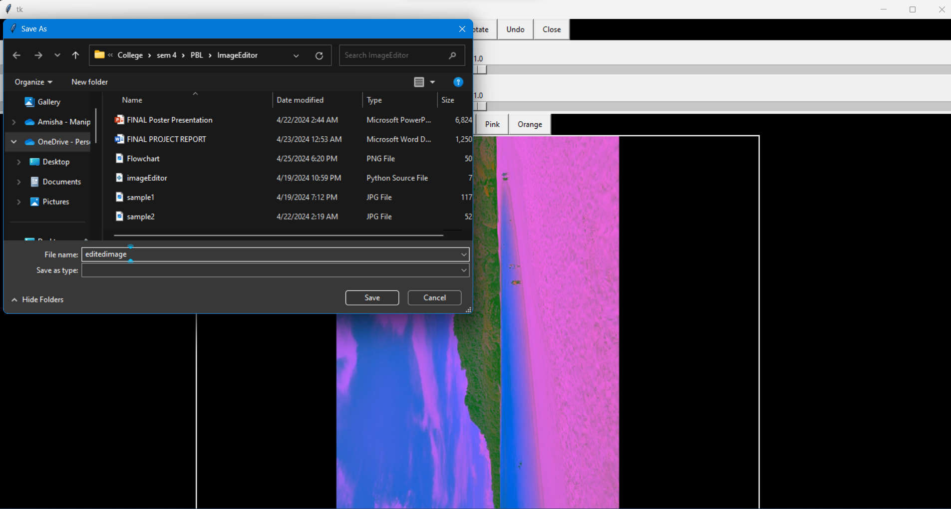

Figure 6: Dialog window opened to save the edited image.

**CONCLUSION AND FUTURE SCOPE**

Using the basic knowledge of python programming languages and its modules, I have created an image editor successfully. The image editor can perform the following functions: -

* + Importing Images
  + Saving Images
  + Rotating Images
  + Adjusting Brightness
  + Adjusting Contrast
  + Adding Color Filters
  + Undoing up to 5 steps
  + Closing the editor

In the end, the created project is basic but has the possibility of future development. With a little more detailed study of python and its associated libraries, it can further be developed by adding other features that an advanced image editor has along with creating new features and tools that can make it unique and more user-friendly.

**BIBLIOGRAPHY**

**STACK OVERFLOW**: https://stackoverflow.com is a question-answer website for professional and enthusiast programmers. It is the flagship site of the Stack Exchange Network. It was created in 2008 by Jeff Atwood and Joel Spolsky.

**GEEKS FOR GEEKS**: GeeksforGeeks is a portal for computer geeks where you will find a bunch of articles, quizzes on programming and algorithm. It is a platform for learning tech related topics, engineering syllabus, it has online as well as offline courses for on-demand topics like C++, Java programming, campus placement etc.

**UDEMY**: ( Complete Python Bootcamp From Zero to Hero in Python) Jose Portilla on Udemy is a great online course to learn Python. It's clear, comprehensive, engaging, hands-on, and at the same time very cost-effective and affordable.

**FREE CODE CAMP**: freeCodeCamp is a non-profit organization that consists of an interactive learning web platform, an online community forum, chat rooms, online publications and local organizations that intend to make learning web development accessible to anyone.

**GITHUB**: GitHub, Inc. is a provider of Internet hosting for software development and version control using Git.

**YOUTUBE**: YouTube helps millions of students & self-taught programmers learn fundamental concepts.